Felix, please see two separate quotes attached.
Both quotes include Andersen E-Series, double hung clad windows with painted white pine wood interior finish and an aluminum exterior in Clay Canyon finish.
The first quote attached includes the colonial divided lite grille.
The second attachment is the same quote previously sent that does not include the divided lite grille.
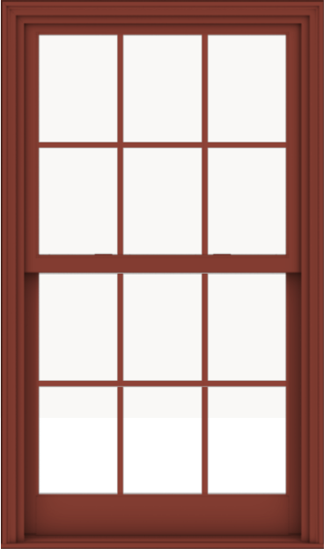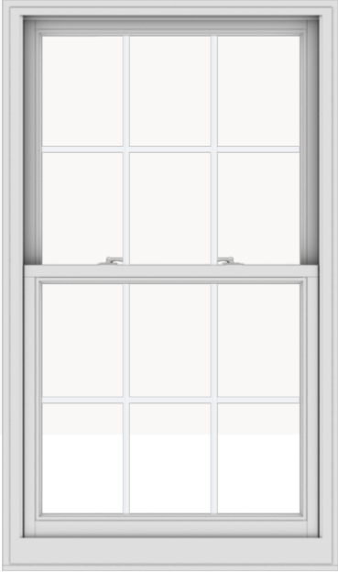 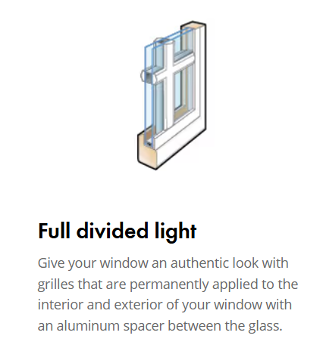 vs 