To Whom It May Concern:

Homeowner, Judi Marshall, is requesting the following modifications to her home at 316 Army Blvd, San Antonio, Tx 78215.
- Install permanent patio structure on existing concrete slab at rear left of house. The structure is intended to replace temporary gazebo-type structures which require replacement every few years.
  - Structure to include screened walls and doors with roof matching the existing roofs of the main house and adjacent areas.
  - Roof of structure to be asphalt shingles matching the existing roofs.
  - Corner support columns to match those of the front porch.
  - Structure to include power for lights and fans.
  - See Exhibit A for existing conditions, example of permanent structure, original prints and drawings of proposed.
- Replace current wood and windows on existing enclosed Rear Porch. Windows are not original to the house which was built in 1905. See original architectural prints on Exhibit B. Proposed replacement windows on same Exhibit. Photos of existing windows are included on word document Windows on Rear Porch.
- Install new wood/composite decking adjacent to existing Rear Porch and existing concrete slab.
  - Deck will extend from concrete patio slab to end of Rear Porch and will have built-in seating and space for hot tub.
  - Install hot tub connected to power and gas.
  - Pergola-type covering for hot tub.
  - Install wooden enclosure for outdoor/rinse off shower.
  - See Exhibit C for all details.

Exhibit A
Existing gazebo street view
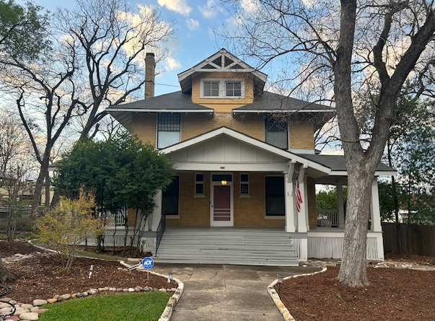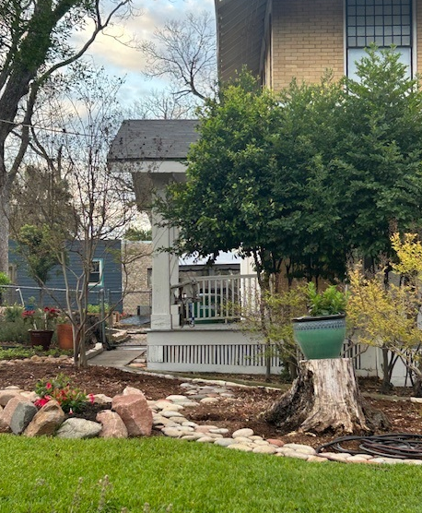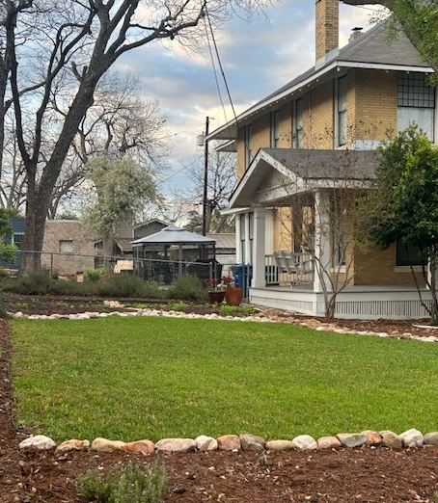
Example of proposed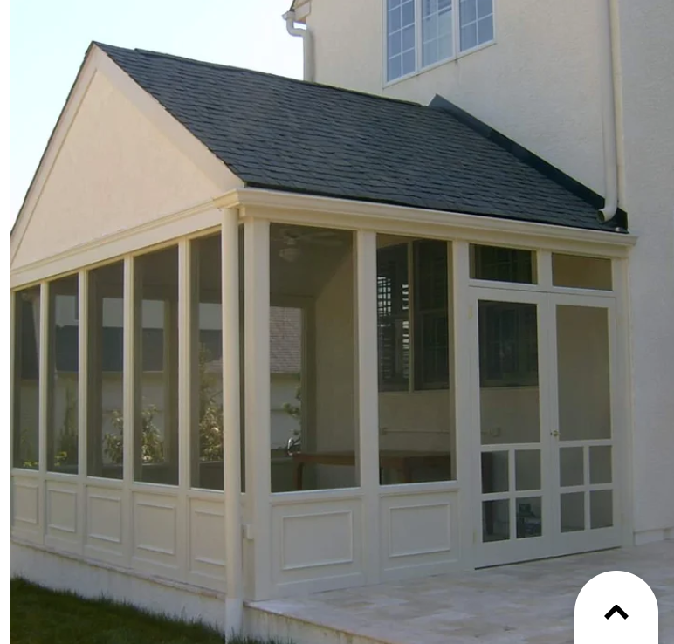
Drawing – Plan View
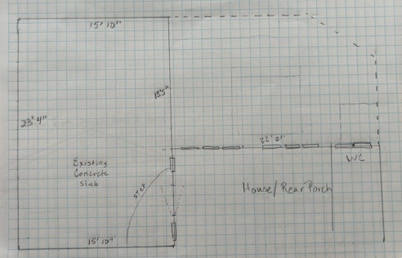

Drawings – Elevations - View from Street, front of house and side
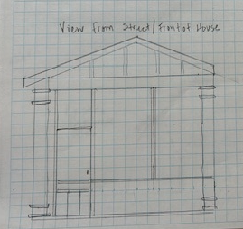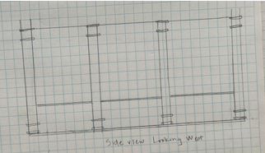

Drawings – Elevations - View from back of house – face North and East
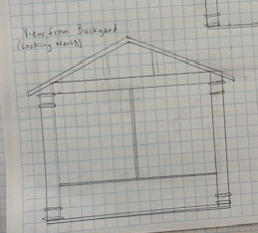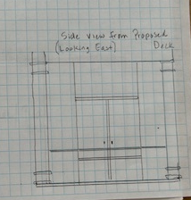

Original Prints:
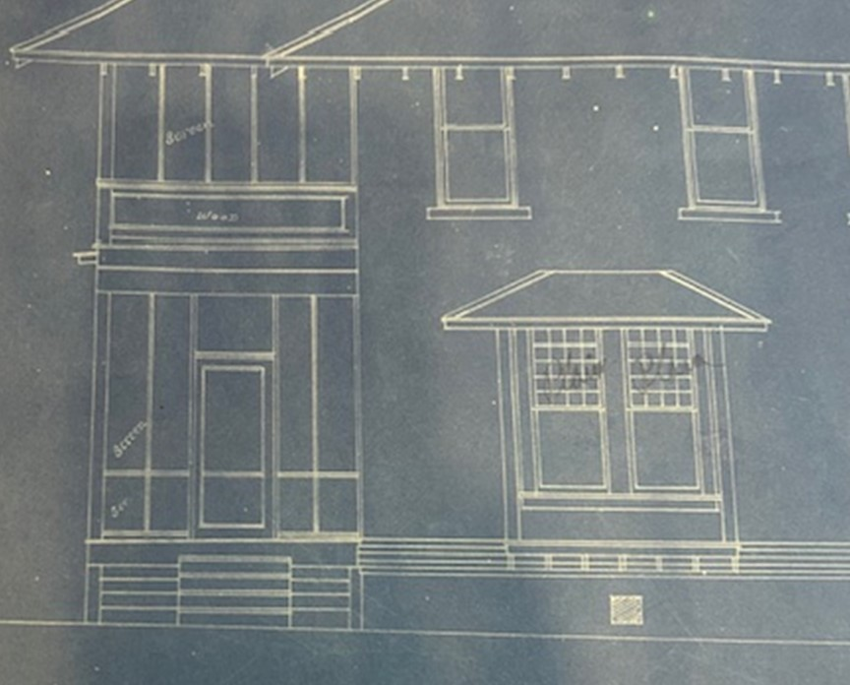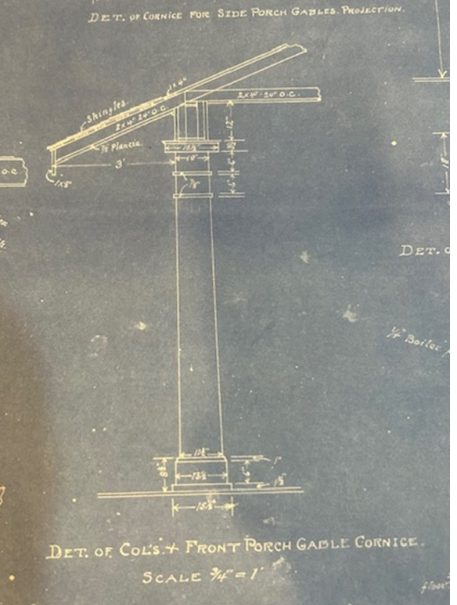

Exhibit B: Rear Porch – Window and wood replacement
Existing Conditions
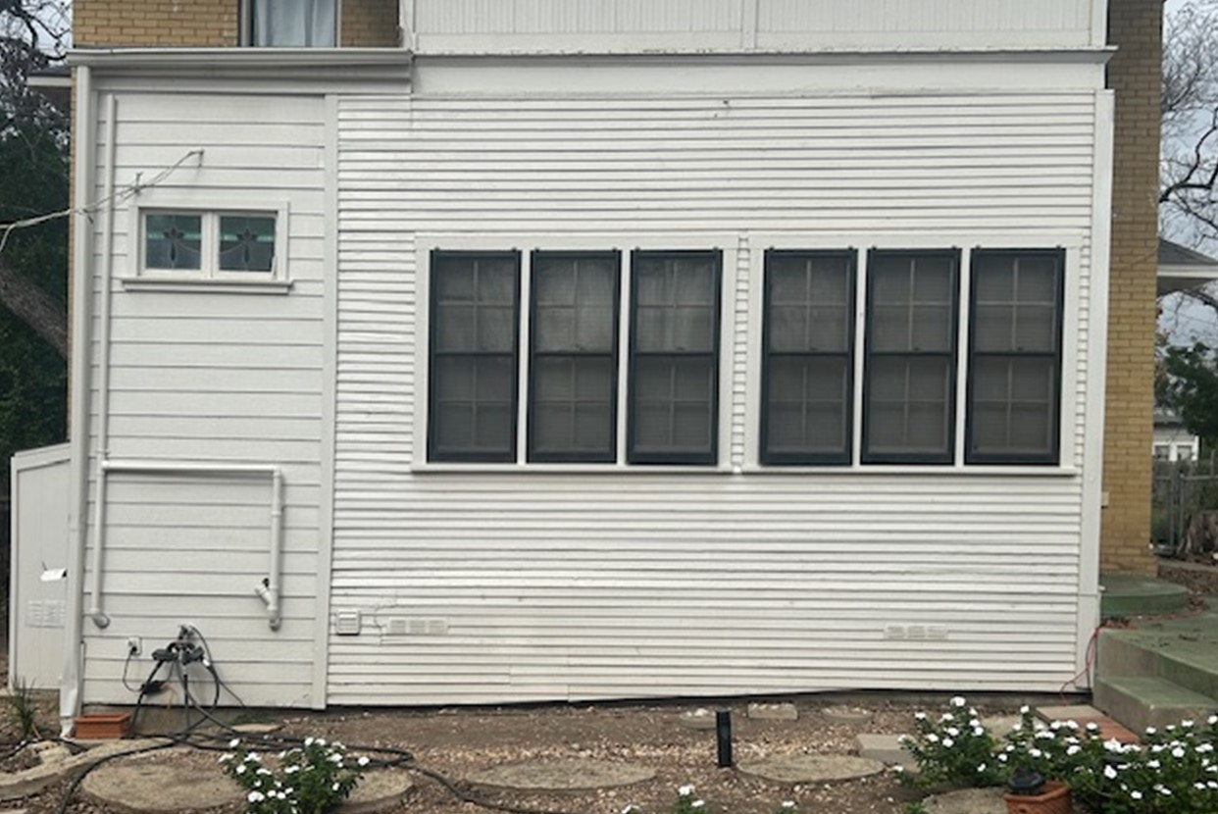
Original Plans
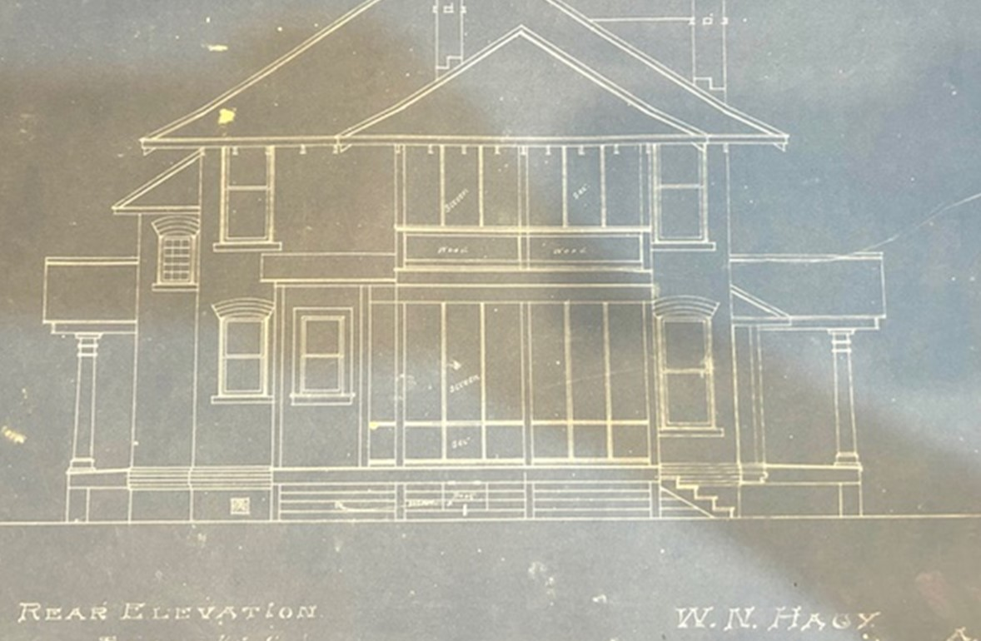
Screens
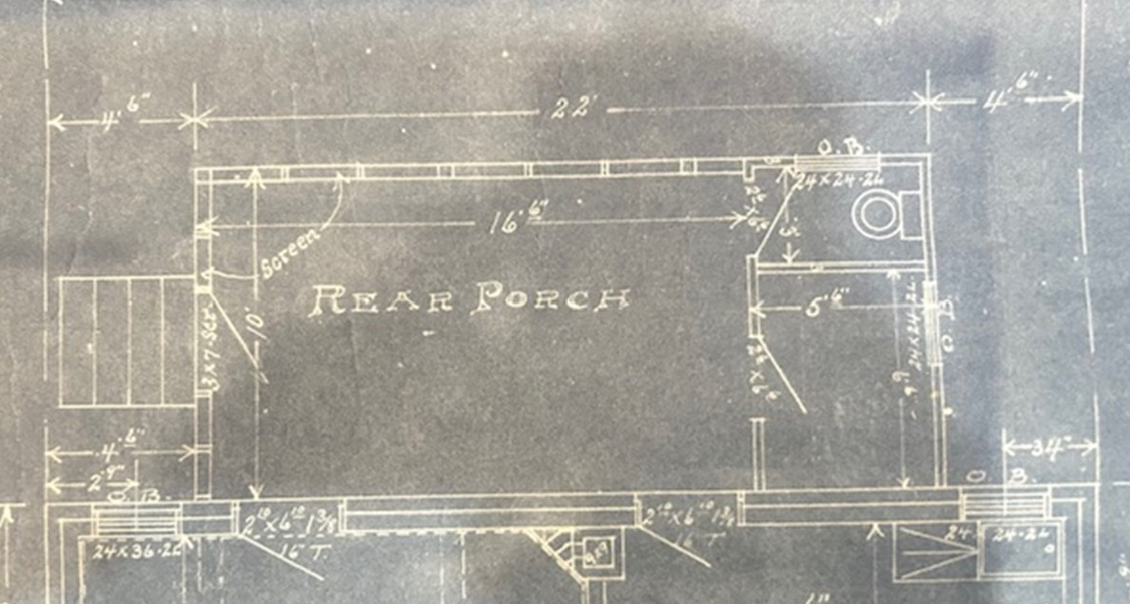

Proposed: (1) Replace all 8 (non-original) windows with OHP guidelines for new construction and additions. Aluminum clad wood window block frame. (2) Replace original wood on back and door section with composite wood (if allowed) to match left section which was altered 25 years ago.
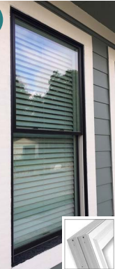

Exhibit C: Add deck adjacent to existing/proposed remodel rear porch and existing green concrete slab. First point in this remodel is adding a permanent structure over the slab.
Existing conditions:
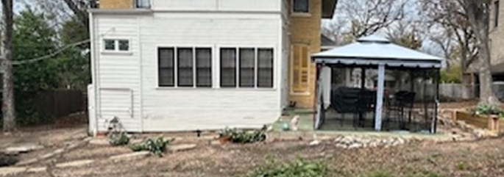
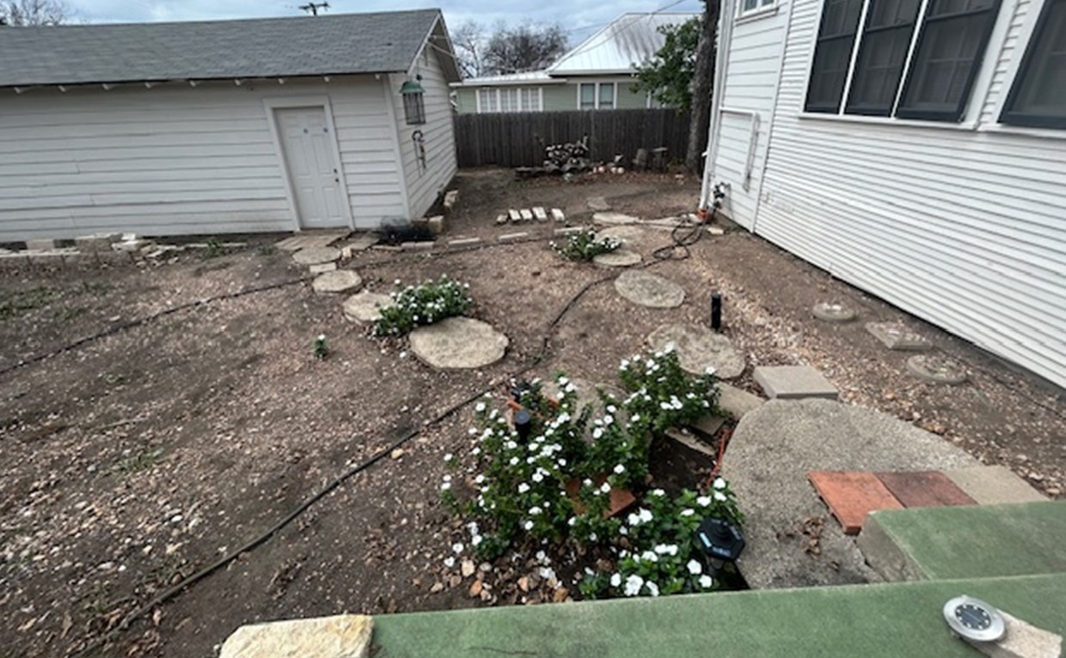

Proposed:
- Install composite decking on right side of existing slab (dotted area)
- Install outdoor shower, outside from existing restroom and wash room
