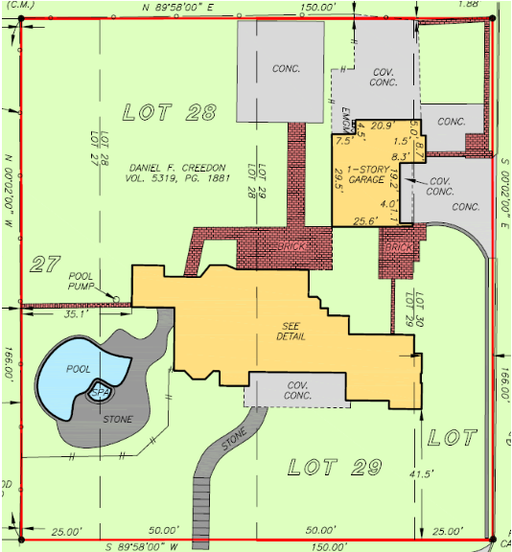

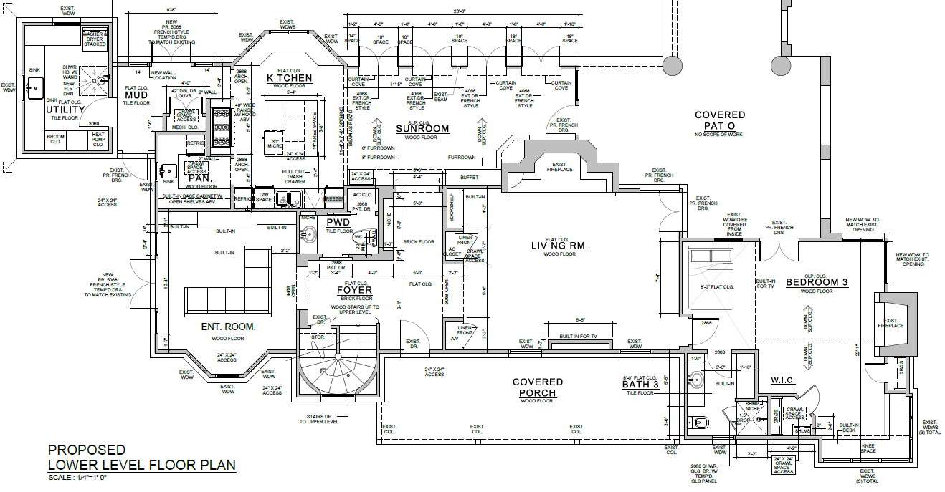

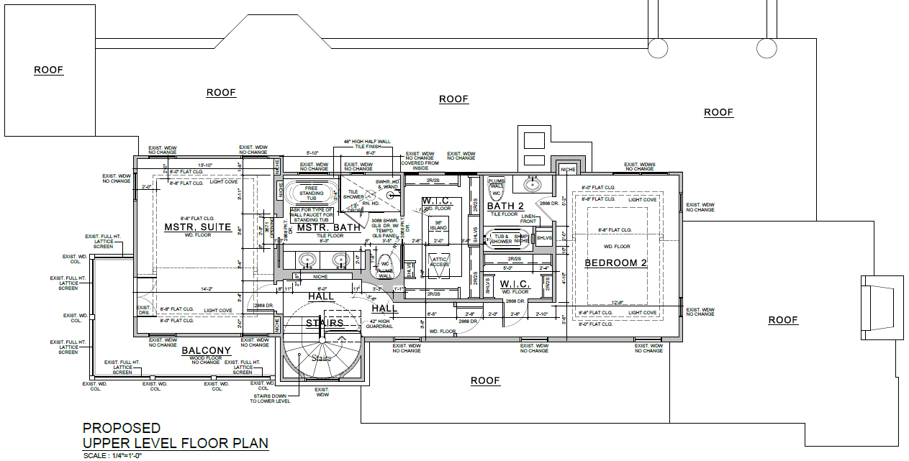

Existing Exterior – South Elevation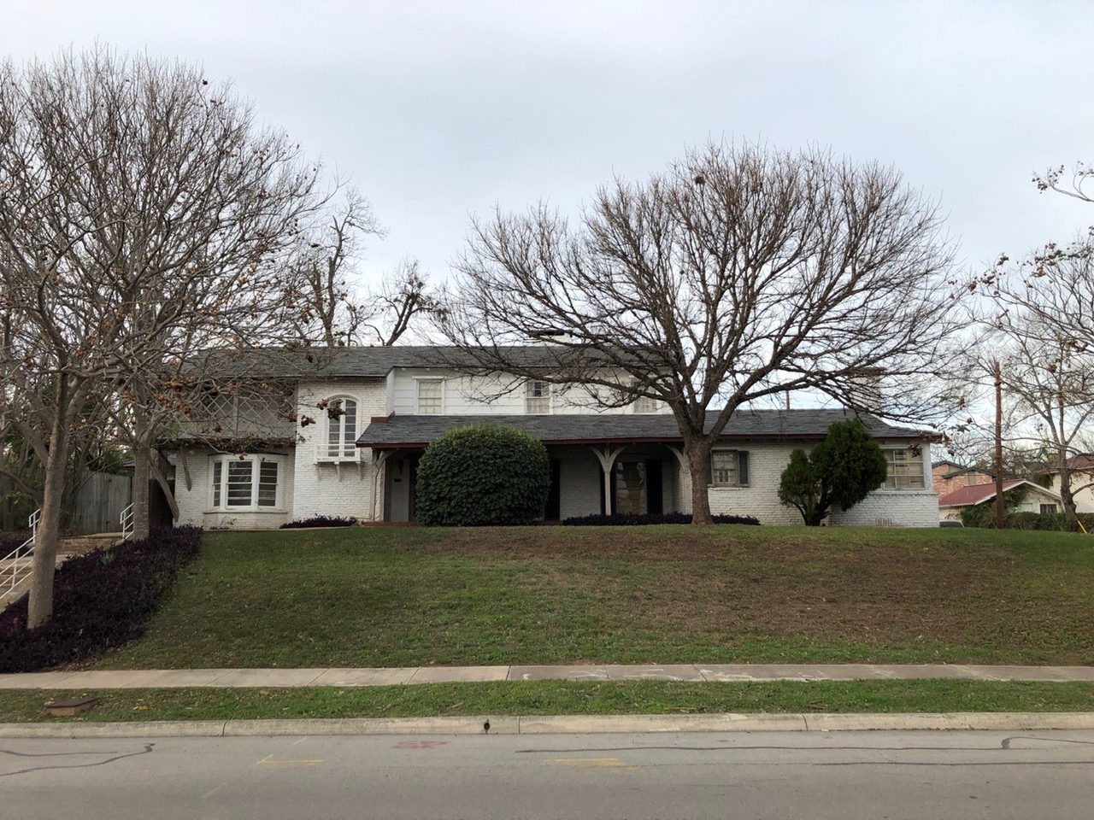
Existing Exterior – East Elevation
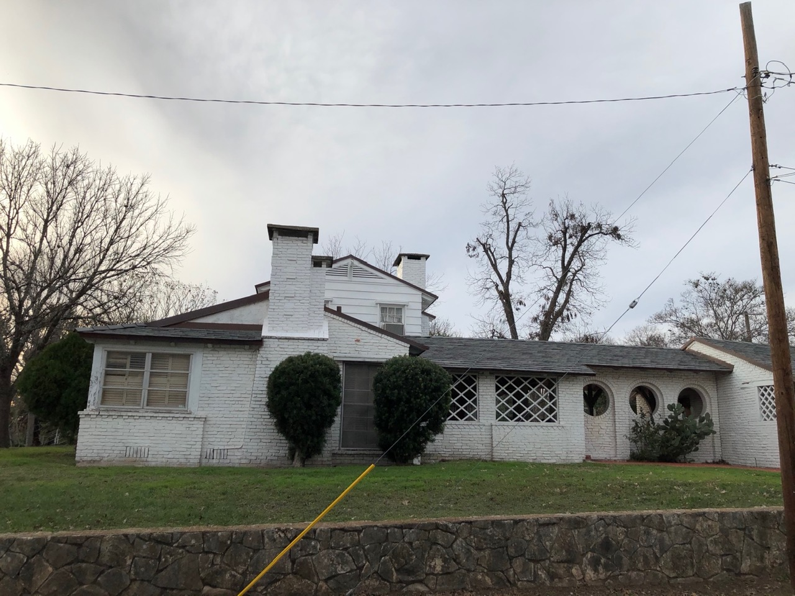
Existing Exterior – NE Elevation 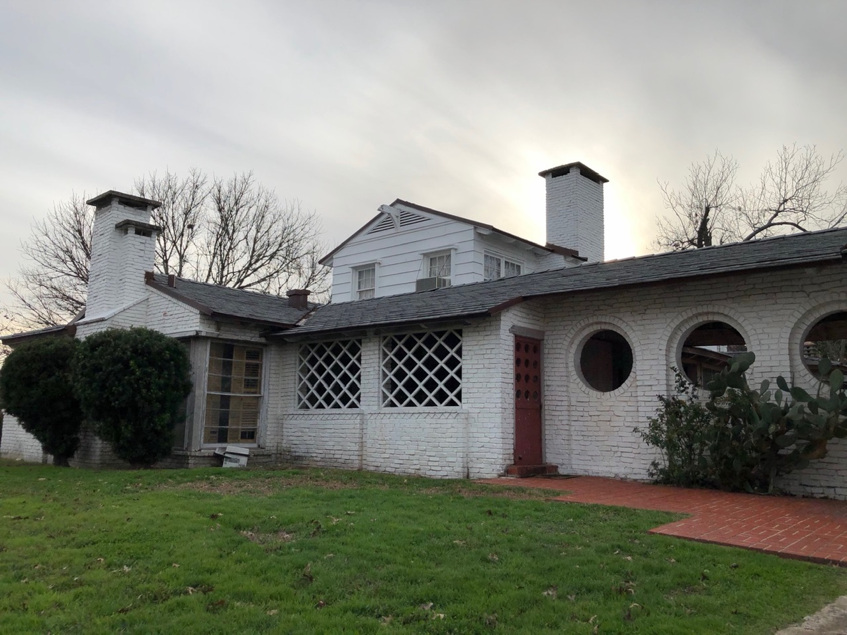
Existing Exterior – N Elevation
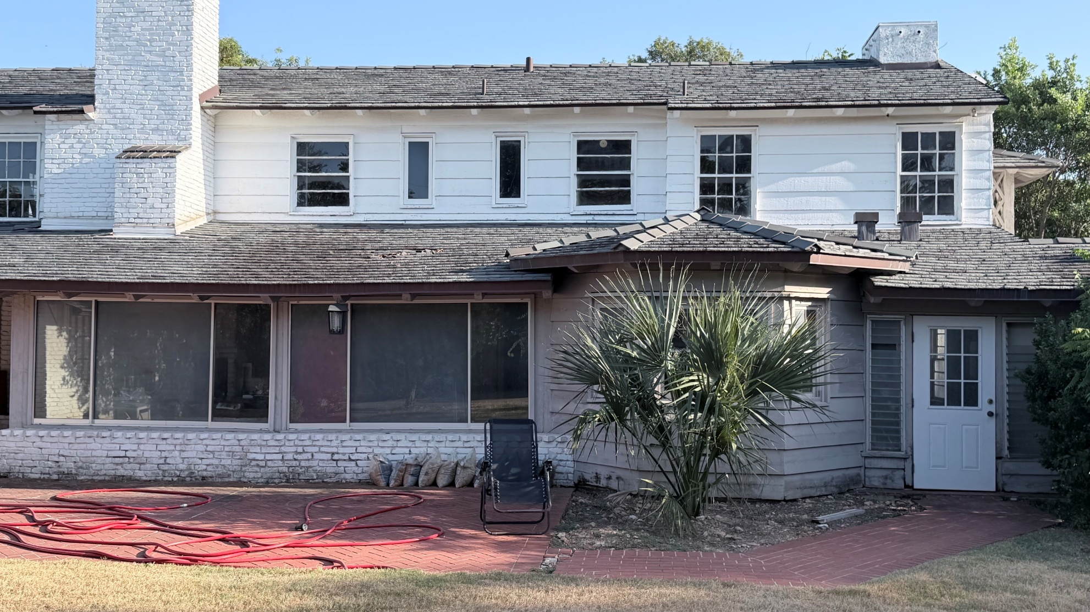
Existing Exterior – W Elevation
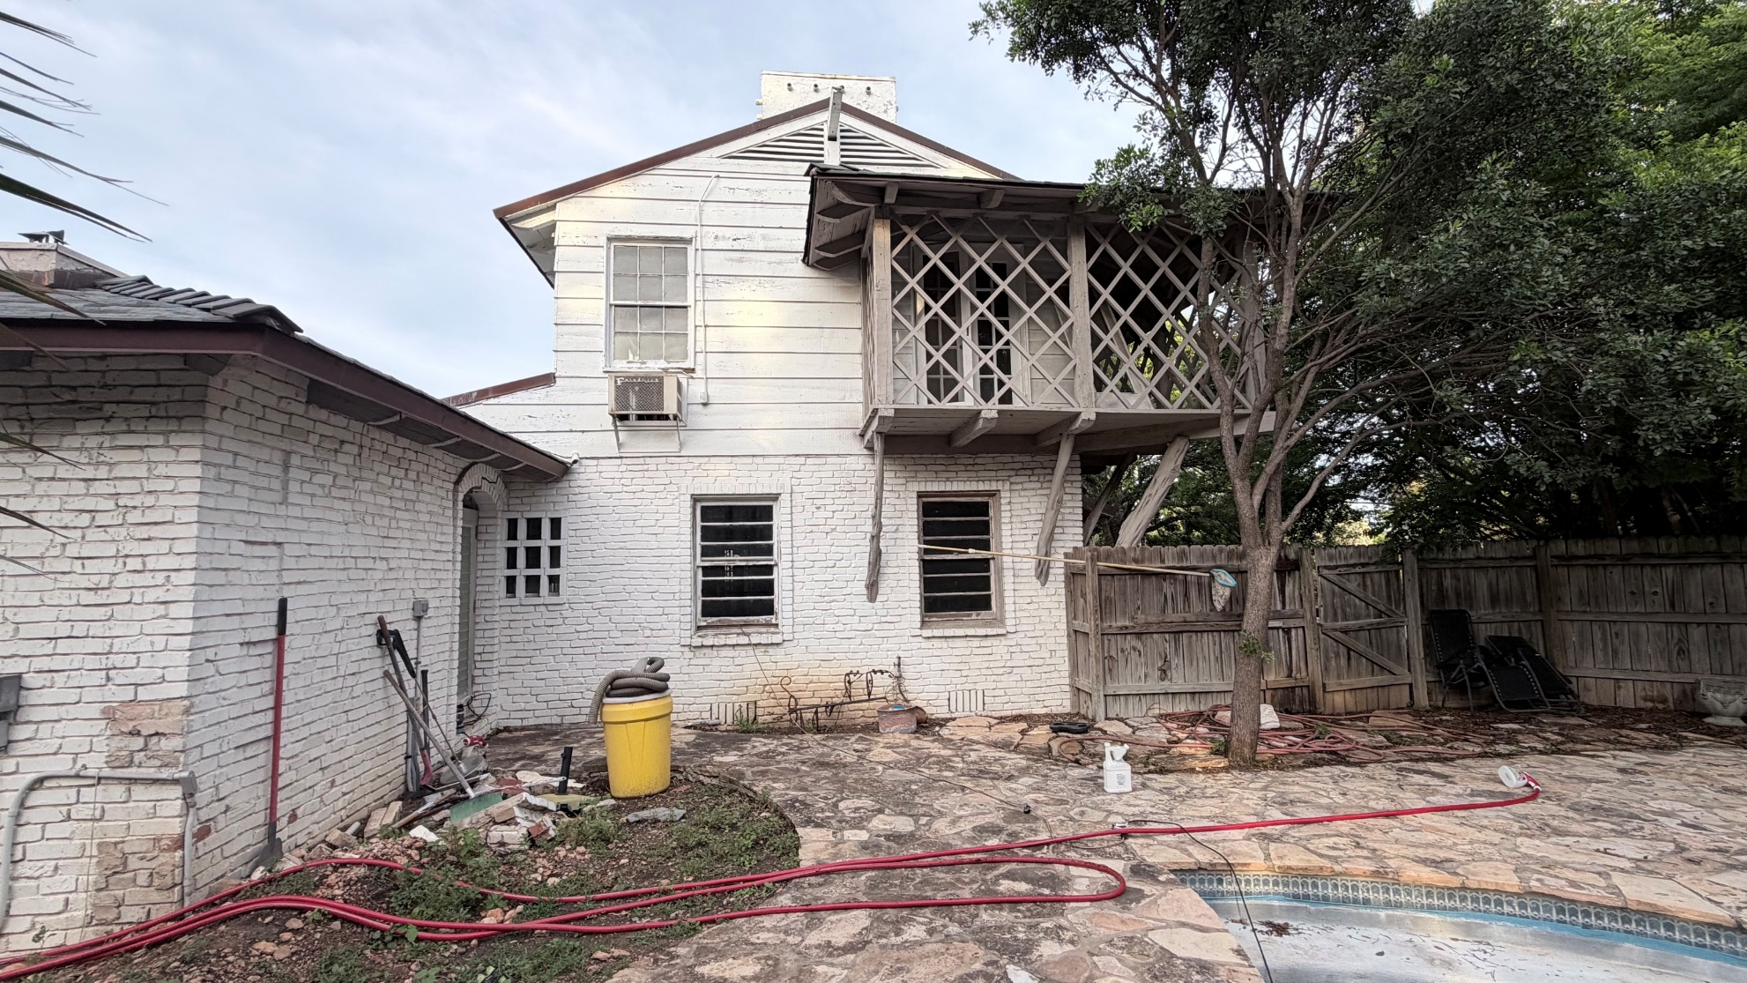

MUDROOM – Remodel North Wall of Mudroom – Replace non-original metal jalousie windows and non-original door with period appropriate 4 panel aluminum clad wood door assembly with divided lites. Install sconces on each side of door assembly.
W-03 — Window | Floor 1 | Mudroom | North - eastmost
W-04 — Window | Floor 1 | Mudroom | North - west jalousie
W-05 — Window | Floor 1 | Mudroom | North - westmost
D-02 — Door | Floor 1 | Mudroom | North

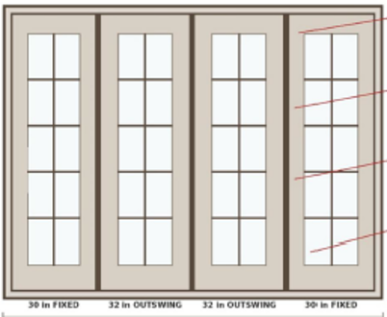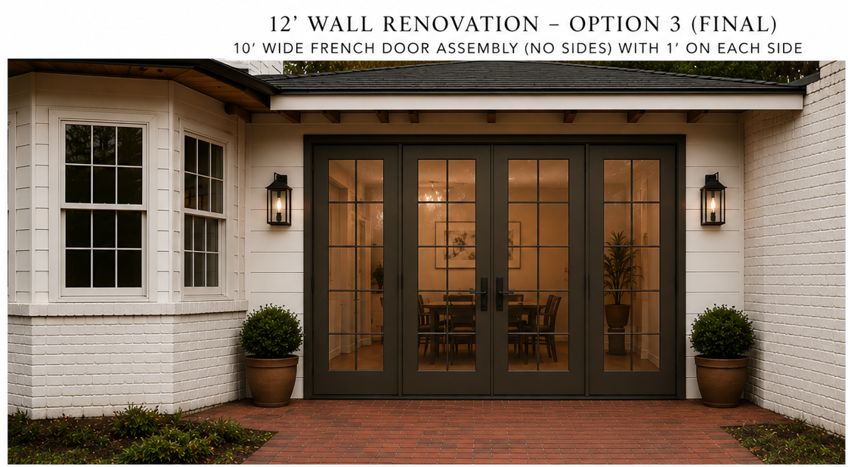

DINING – Remodel/Redesign North Wall of Dining in previously enclosed patio – remove non-original metal windows. Increase the lower part of opening to install four aluminum clad wood French patio doors. Install sconces on each side that match mudroom.
W-10 — Window | Floor 1 | Dining | North - west assembly
W-11 — Window | Floor 1 | Dining | North - east assembly
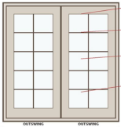 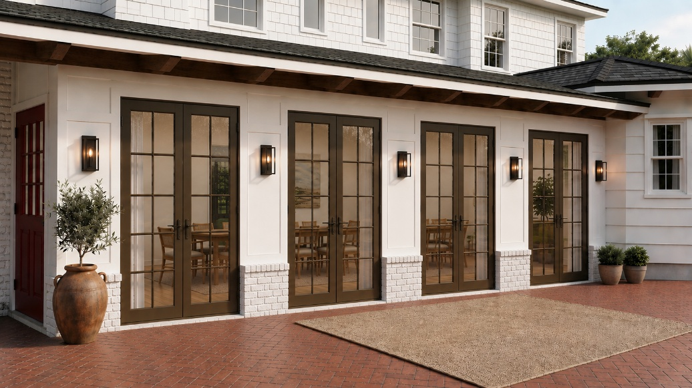

DEN – Remodel/Redesign west wall of den to allow access to pool – remove original windows and replace with historically appropriate 4 panel aluminum clad wood door assembly with divided lites. Use wood from removed windows to repair/refurbish damage on other historic windows throughout the house.
W-13 — Window | Floor 1 | Den | West - North Window
W-14 — Window | Floor 1 | Den | West - South Window
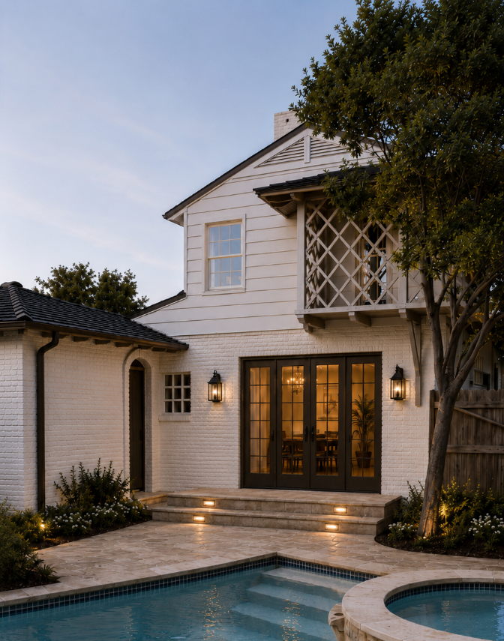

EAST WING NE – Replace large damaged and failing windows with aluminum clad wood windows with historically appropriate style and divided lites
W-22 — Window | Floor 1 | East wing NE corner | North face
W-23 — Window | Floor 1 | East wing NE corner | East face
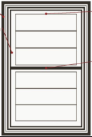 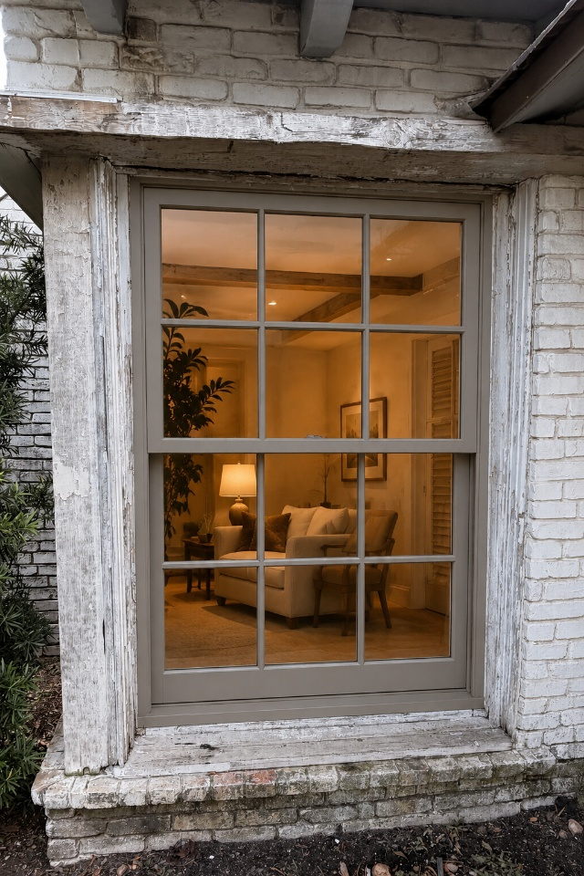
EAST WING SE – Replace large metal windows with aluminum clad wood matching windows in NE corner
W-24 — Window | Floor 1 | East wing SE corner | East Facing
W-25 — Window | Floor 1 | East wing SE corner | South Facing
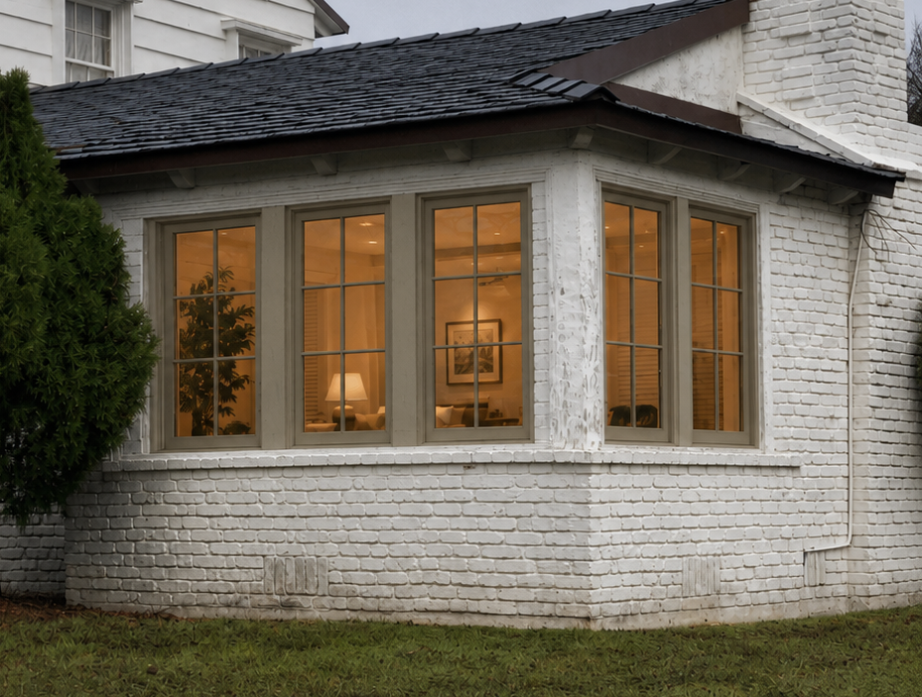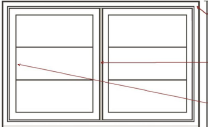

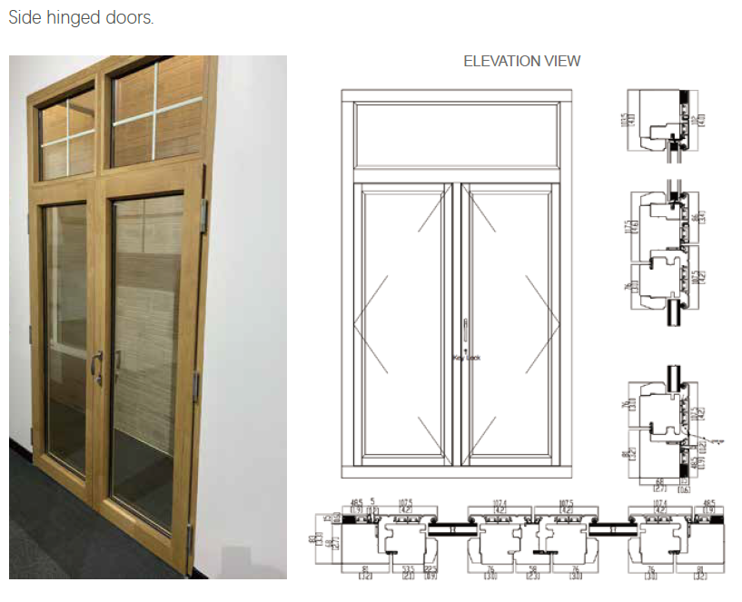
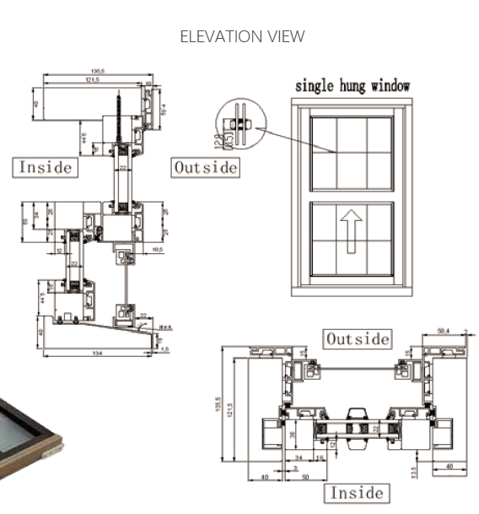

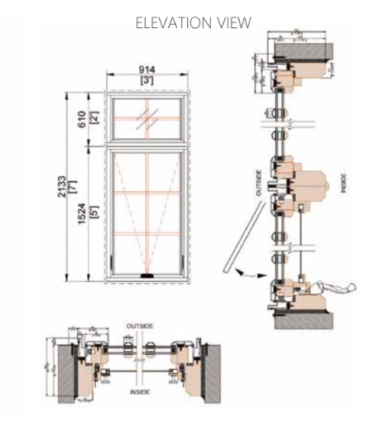

Proposed Exterior Color Scheme:
Brick: Creamy White – e.g. Sherwin Williams Alabaster White
1st Floor Window Sash and Trim: Medium Warm Gray/Greige – e.g. Sherwin Williams Anew Grey or Mega Greige
2nd Floor Window Sash and Trim: Creamy White – e.g. Sherwin Williams Alabaster White
Exterior Entry Doors: Grey Bronze – e.g SW Urbane Bronze
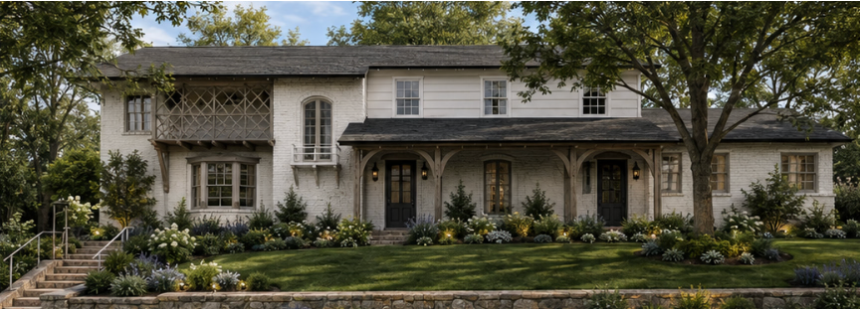
**Example of color scheme only. Some architectural details are not accurate.

